

Step-by-Step Implementation Guide

Enterprise Standards for Information Security (IE3102)

Perera R.Y IT22552488

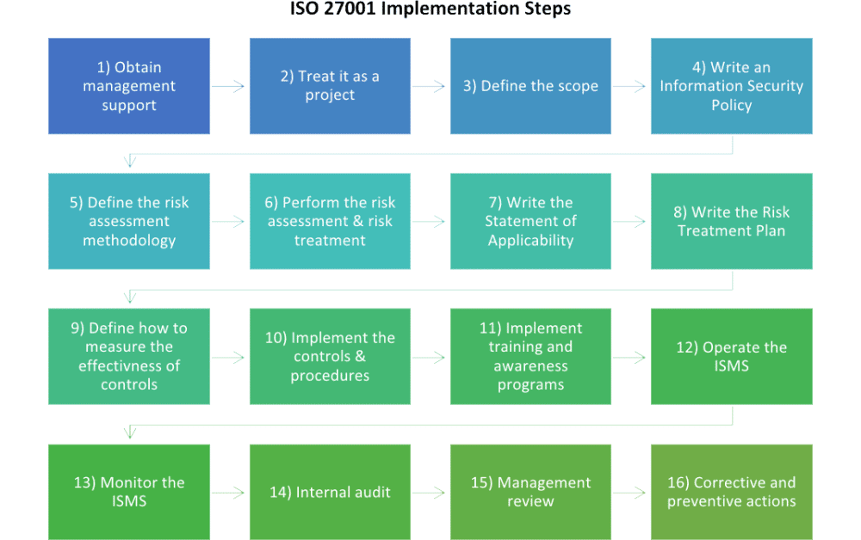

This guide outlines the necessary steps to successfully implement ISO 27001 within your organization. Follow these steps closely, ensuring each phase is fully understood and implemented as part of your Information Security Management System (ISMS).

**1. Obtain Management Support**

Gaining top management’s commitment is crucial to the success of the ISO 27001 project. Without their support, resource allocation (time, personnel, and budget) may be insufficient. The implementation process often fails due to a lack of proper involvement from leadership. Therefore, securing strong management backing should be your first step.

**Tips:**

* Present a clear business case to management.
* Highlight the benefits of ISO 27001, including risk reduction, customer trust, and compliance.

**2. Treat ISO 27001 as a Project**

The implementation of ISO 27001 is a multifaceted project that involves significant organizational change. Treat it like any other complex project by setting clear goals, assigning responsibilities, and establishing timelines. Proper project management is essential for successful and timely completion.

**Suggestions:**

* Develop a project plan.
* Assign a dedicated project manager and team to oversee the implementation.
* Create a communication plan to keep stakeholders informed.

**3. Define the Scope**

Determine which parts of the organization are to be included in the scope of your ISMS. For larger organizations, it may be advantageous to focus on certain departments or functions, whereas smaller companies might find it easier to cover the entire organization.

**Key Considerations:**

* Consider regulatory requirements and risk exposure.
* Align the scope with strategic business goals.

**4. Write an Information Security Policy**

The Information Security Policy is the foundation of your ISMS. While it should not be overly detailed, it must outline the organization's approach to information security, as well as its objectives and management responsibilities.

**Figure Idea**: A diagram depicting the hierarchy of information security policies, from the ISMS Policy down to procedures and guidelines. **Placement**: After this section to visually represent the structure.

**5. Define the Risk Assessment Methodology**

A structured risk assessment methodology is vital for identifying and addressing information security risks. This methodology should specify how risks are identified, evaluated, and treated. Clear rules on risk acceptance and treatment must be in place to ensure the methodology is consistently applied.

**Suggestions:**

* Align the methodology with your business objectives and risk appetite.
* Use qualitative or quantitative methods as applicable.

**6. Perform the Risk Assessment & Risk Treatment**

Once your methodology is in place, conduct the risk assessment to evaluate potential risks to the organization. This step involves identifying assets, vulnerabilities, and threats to determine risk levels. Based on the assessment, implement risk treatment strategies, primarily using controls from Annex A.

**Key Tasks:**

* Document the Risk Assessment Report.
* Obtain approval for residual risks.
* Draft a Risk Treatment Plan, detailing how to mitigate unacceptable risks.

**7. Write the Statement of Applicability (SoA)**

The SoA lists all the ISO 27001 controls from Annex A and states which ones are applicable, which are not, and why. It’s also essential for getting management approval for your ISMS. This document is crucial for auditors as it explains your control environment.

**8. Write the Risk Treatment Plan**

Your Risk Treatment Plan focuses on how controls from the SoA will be implemented. It provides a detailed roadmap of who is responsible for each control, what resources are needed, and the deadlines for implementation. Without this plan, your ISMS implementation could lack structure and progress.

**9. Define How to Measure Control Effectiveness**

To verify the success of your ISMS, you must establish metrics to measure the effectiveness of your controls. If controls are not measured, you won’t know whether they are working as intended.

**Considerations:**

* Define key performance indicators (KPIs) for security processes.
* Regularly review metrics and adjust as necessary.

**Figure Idea**: A table illustrating sample KPIs for various controls. **Placement**: After this section, provide examples of performance measurement.

**10. Implement the Security Controls**

Implementing the controls is the most challenging aspect of the ISO 27001 project. It requires changes to policies, procedures, and sometimes technology. This is also where new security behaviors must be adopted across the organization.

**Challenges:**

* Overcome resistance to change by ensuring everyone understands the reasons behind the new measures.
* Create detailed implementation procedures to ensure consistency.

**11. Implement Training and Awareness Programs**

For controls to be effective, employees need to be aware of and trained on new policies and procedures. ISO 27001 implementation often fails due to a lack of awareness, so training programs are critical to a successful rollout.

**Figure Idea**: An infographic showing the flow of information from training programs to awareness and employee adoption. **Placement**: Following this section, illustrating the impact of training on control adoption.

**12. Operate the ISMS**

Once your ISMS is in place, its operation becomes part of daily organizational processes. Regularly collect and maintain records to ensure you are adhering to the ISMS. These records will also be key during audits to demonstrate compliance with ISO 27001.

**Suggestions:**

* Use logging and monitoring systems to ensure real-time tracking of activities.
* Conduct regular checks to maintain system integrity.

**13. Monitor and Measure the ISMS**

This is where you evaluate the effectiveness of your ISMS by reviewing incident reports, monitoring the performance of controls, and measuring key security metrics. Regular monitoring helps to spot weaknesses and implement corrective actions.

**Figure Idea**: A flowchart depicting the incident response process from monitoring to corrective actions. **Placement**: At the end of this section, providing a visual summary of the monitoring and measurement cycle.

**14. Conduct Internal Audits**

Internal audits are essential for identifying non-conformities and areas for improvement. Regular audits ensure that the ISMS is functioning as expected and that employees are following the established procedures.

**15. Management Review**

Top management must review the ISMS regularly to ensure it continues to meet the organization’s goals and external requirements. This review is crucial for maintaining management support and securing ongoing resources for information security.

**16. Implement Corrective Actions**

Whenever non-conformities are identified, corrective actions must be taken. These actions should address the root cause of the issue to prevent its recurrence, ensuring that the ISMS remains effective and compliant with ISO 27001.